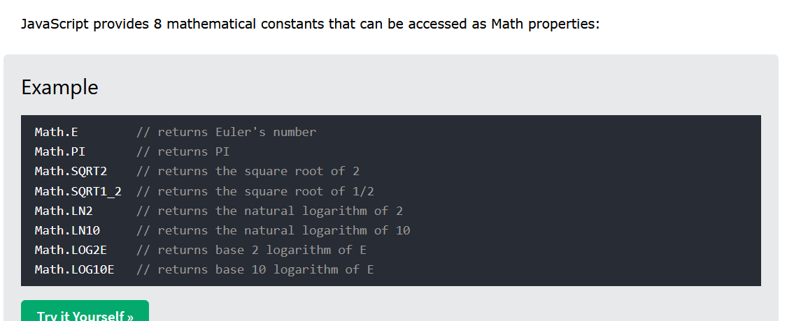

It covers almost every constants used in Math

To Convert any Number To Integer

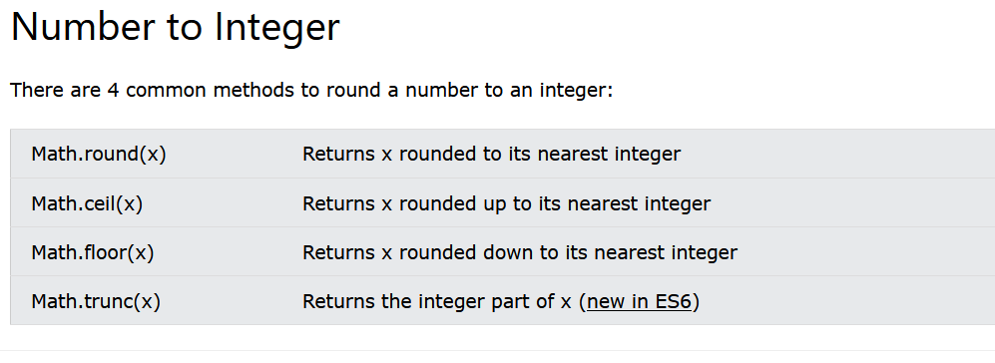

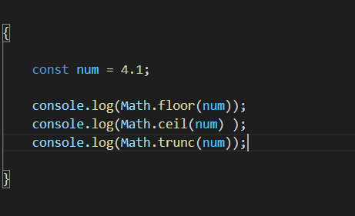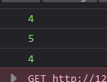

Math.trunc( )

It returns us the integer part of the given Number data type

Math.floor( )

It round down the Number

Math.ceil()

It rounds up the number

**To determine the positive, negative number we have Math.sign()**

It returns 1 if passed Number is positive

-1 if passed Number is negative

0 if passed Number is zero

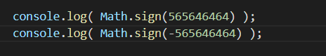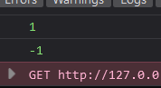

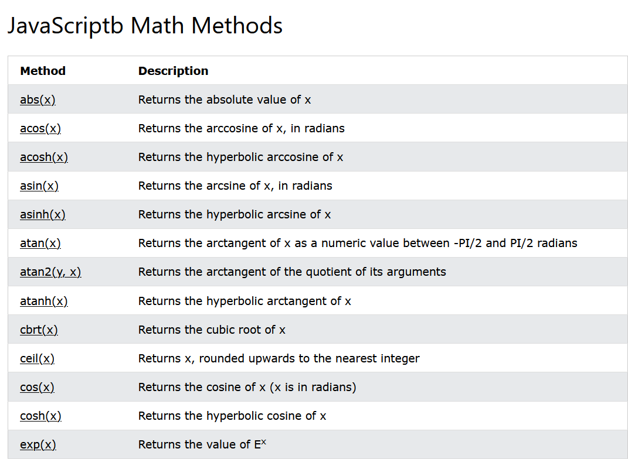

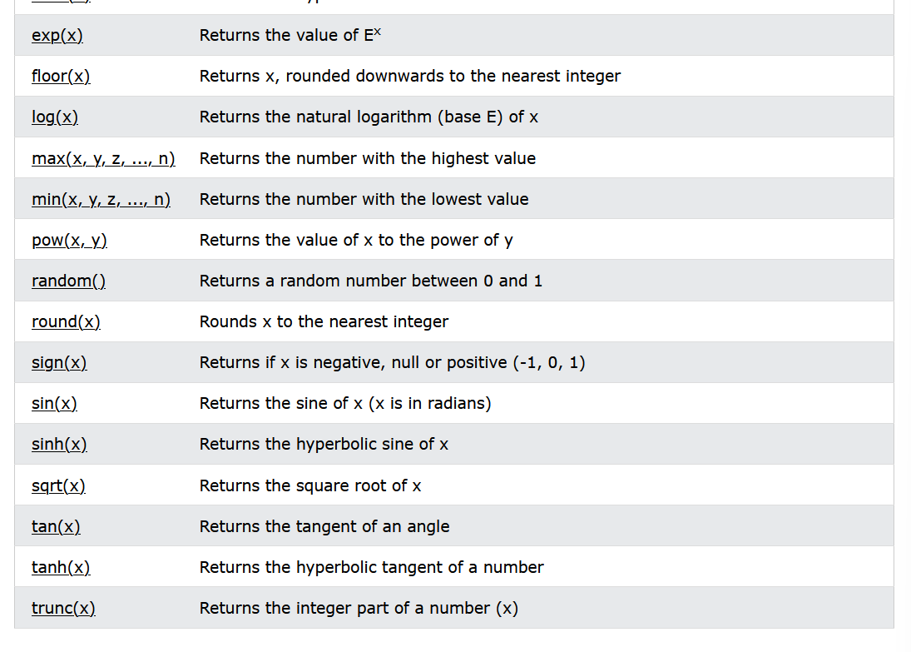

We can do things like

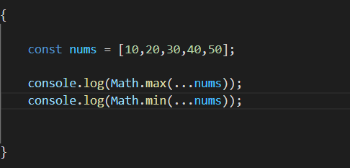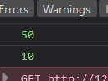

We use spread operator to spread the content inside the array